Sibelius: Step by Step Tutorial Guide: Albongo

Sign into your computers and open Sibelius. Follow these step by step directions.

Step 1: Creating the Score

1. Select blank manuscript and Change Instruments
2. From the African Unpitched Percussion menu, choose djembe, then Add to Score
3. Also choose gankokwe, then add to score and shaker, shekere, then add to score.
4. After you have added all three instruments to your score, click OK.
5. Go through the menu and select 4/4 for the time signature
4. Check metronome mark, quarter note equals 120
5. Select no key signature from the drop down menu and then no key.
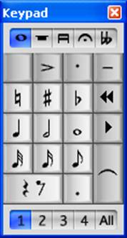
6. Add title in Score Info: Albongo (your name)
Please put your name in the title to make grading easier
7. Add composer: (In this case, it’s a traditional folk song) so just write, traditional.
8. Select Create

Step 2: Adjusting the Layout

1. Home Tab
-Find the Add+ Measure tool
-Select Add Bar at the End
-How many measures do you need to add? ______
2. Layout Tab
-Click on the bar line where you want a line break
-Select System Break
3. Notations Tab
-Select barline to add repeat signs
- Which measure needs a start repeat? Which needs an end repeat?

Step 3: Inputting notes into the Djembe Part

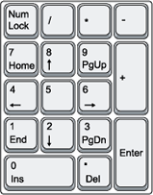
1. Select first measure of the djembe part
2. Type the letter N to start inputting notes into that measure
3. Use the keypad on keyboard to select the quarter note
4. Click the first quarter note in the measure with your mouse.
5. Select eighth note rhythm and type the note B
6. Continue to enter all of the notes in measure 1
7. Cut and Paste will be your BEST Friend
-highlight measures Ctrl C (copy) – select new measure – Ctrl V (paste)
8. Enter all notes and rhythms for the djembe part
9. The back button can be used if you make a mistake
10. Don’t forget to add the accent on the last note!! Can’t hear it? Read on!!

Step 4: Inputting notes into the Gankokwe and Shekere Parts
1. Enter all of the notes into the gankokwe part just like you did for the djembe part.
2. Are you able to hear anything? We need to change the shape of the noteheads to hear the sound.
3. Triple click in the first measure of the gankokwe part to select the entire part.
4. Notations Tab
- select notehead type
- select arrow up shape (alt+shift+14)
5. Did you notice that you couldn’t hear the last note of the djembe part?
-try to figure out which notehead to use
5. Enter all of the notes for the shekere part. You won’t have to change the noteheads

Step 4: Adding the Text

- Select the measure where you want to add text.
- Navigate to the text tab.
- Under styles, click the arrow for more.
- Under common, select tempo.
- Type your text.
- For the first one, you may have to drag the text after you type it so that it doesn’t collide with the metronome marking.

Remember to SAVE OFTEN

When your composition is complete please print and put it on my desk.

