Teacher - Joel Frisch  Email: Joel.Frisch@hcps.org  Phone: (240) 308-8298  Band App: See QR Code on next page (best method)  Availability (Office Hours): 7:00-7:20 (before school),  10:35-11:00 (first lunch), 2:15-3:00 (after school) | C. Milton Wright Guitar  Course Syllabus 2023-2024

Course Description
This course provides the student an opportunity to learn guitar skills and techniques through the study of various styles of music. Guitar Lab and Guitar Ensemble are designed to develop the basic skills necessary to be a successful performer and overall musician through the study of music theory, vocabulary, historical references, performance opportunities, improvisation, and composition. Students may take this course more than one time.

Course Outcomes
- Students will demonstrate the ability to perceive, perform, and respond to music.
- Students will demonstrate an understanding of music as an essential aspect of history and human experience.
- Students will demonstrate the ability to organize musical ideas and sounds creatively.
- Students will demonstrate the ability to make aesthetic judgments.
- Students will demonstrate an understanding of music notation in order to perform a variety of repertoire.

Assessment
The following forms of assessment will be used during the course of the school year:
- Practice (20%) - daily classwork, homework, practice technique
- Process (30%) - quizzes (playing/written), critique/reflection/vocabulary activities
- Product (50%) - tests (playing/written), class projects

Grading Outline
The student’s grade will be derived from the following areas:
- Class Preparation/Participation – Students are expected to exhibit the following work habits:
  - Active participation and preparation for class (notebook, book, pencil, etc.)
  - Cooperation
  - Punctuality
- Progress/Achievement – A student’s developing knowledge and skill base will be assessed by tests and quizzes. Most tests will be written. There will also be tests in the form of long term projects.
- Homework – Students are expected to turn in homework on time. Late homework can be accepted with a grade deduction.

Required Supplies
- Instrument - provided
- Pencil - every class, NO EXCEPTIONS
- Three Ring Binder w/ 3 sections (Exercises, Classwork, Songs)
- Music Stand – provided
- Guitar Picks - light/medium gauge or your preference
- Snark Tuner - optional

Required Apps
- Metronome:
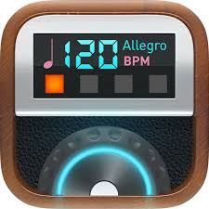 | Pro Metronome  FREE on Apple and Android  Paid version ($3.99) is recommended

- Tuner (if you do not own a Snark Tuner)
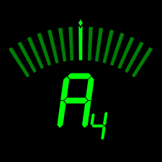 | DA Tuner by Prometheus Interactive  FREE on Android, not available for Apple  Paid version ($2.99) is recommended
Tunable
FREE on Apple, $3.99 on Android
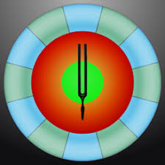 | Tonal Energy (also includes a metronome)  $3.99 on Apple and Android
iStroboSoft (for bass)
$9.99 on Apple
Strobe Tuner Pro by A4tune Labs (for bass)
$2.99 on Android

Classroom Procedures/Expectations:
It is necessary for all students to observe and obey the following rules for this class to ensure a positive learning environment. Any student who is unable to follow these guidelines will have their guitar privileges revoked for a time period determined by the teacher. All students will adhere to the following:
- Be ON TIME and BE PREPARED.
- Be RESPECTFUL of other students and of Dr. Frisch.
- Absolutely NO drinks (other than water), food, gum, or headphones. Cell phones may be used ONLY when instructed to do so.
- Play ONLY the guitar assigned to you and ONLY during instructed playing time.
- Your guitar must either be in your hand or safely placed on a guitar stand at all times.
- The guitar is a musical instrument and should be treated with respect.
- At the beginning of each class, you will take a music stand and a guitar stand and put them away as you exit.
- During virtual instruction, please adhere to the following:
  - Mute your microphone upon entering the virtual classroom
  - Be in front of your screen and dress appropriately
  - Be prepared with all essential materials (see Course Materials on page 3)
  - Wear headphones

Attendance
Attendance is mandatory to achieve success. You are responsible for all work when you are absent from class for both excused and unexcused absences. Please do not request makeup work at the beginning of class. Instead, please come find me during my available office hours. If you are absent from a class, I will expect you to have a note upon your return.

Attendance at concerts is MANDATORY and will be a 100 point performance grade. Failure to participate in performances without a valid reason for your absence will result in a zero. Absences from this performance for which the grade penalty will be imposed include, but are not limited to the following:
- Work
- Concerts/Sporting Events
- School work – The rotating schedule provides you with ample time to complete your homework, if you are responsible and plan ahead.

VIII. Academic Integrity Policy
Academic dishonesty, including but not limited to cheating, assisting, misrepresentation, and plagiarism (CAMP) will not be tolerated. Please refer to the student handbook for more information about academic dishonesty and its consequences.

Dates and Events
Date | Event | Time | Location | Points
May 10, 2023 | Spring Concert | 7:00 pm | CMW Auditorium | 100 points

Concert Attire
Students are expected to wear the following for the CMW Spring Guitar Concert:
- CMW Guitar Shirt (purchase)
- Dark long pants or jeans: pants must not have rips
- Sneakers or tennis shoes

